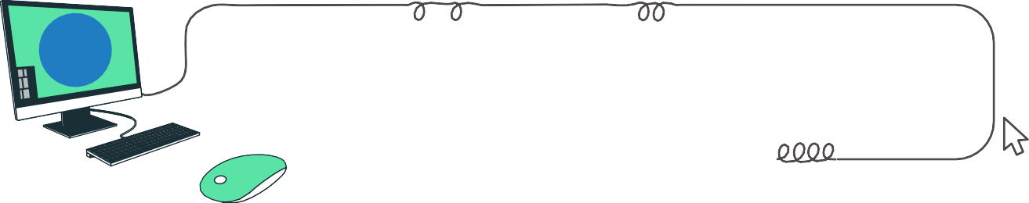
Introduction To C Programming
1



SESSion OVERViEw



In this session, you will delve into the basics of computer program, algorithm and flowchart, and the basics of C programming.

LEARning ObjEcTiVES

By the end of this session, you will be able to,
- Define computer programs
- Describe algorithms and flowcharts
- Explain the features of C programming

Have you ever wondered how machines handle daily tasks like washing clothes, cleaning dishes, or playing music with Alexa? What’s happening behind the scenes?
These machines run on computer programs which are step-by-step instructions that tell them what to do. But what exactly are these instructions, and how do they work? Let’s explore!

Computer programs
A computer program is a set of instructions that tells a computer/machine what tasks to perform.

  - Algorithm
An algorithm is defined as a set of step-by-step instructions designed to solve a particular problem or perform a specific task. They are important in programming
because they help solve problems in an organised and efficient way.
Example: Algorithm for Brushing Teeth:
- Rinse the toothbrush under running water.
- Apply toothpaste to the bristles.
- Put the toothbrush in your mouth and begin brushing in a circular motion.
- Brush all areas of the teeth, including the front, back, and chewing surfaces.
- Spit out the toothpaste and rinse your mouth with water.
- Wash the toothbrush and store it in a clean, dry location

That’s computational thinking which involves analysing a problem, finding a logical solution, and following a clear process!

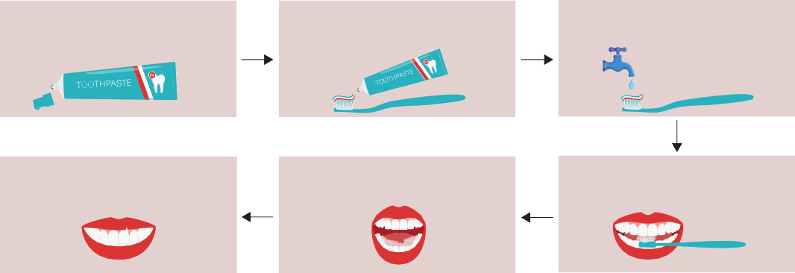
Algorithm - Steps to brush your teeth
02. onto the brush
Squeeze Toothpaste
05.
Spit out the toothpaste and rinse the brush
03. the brush
Run a little water on
06.
TADA!!
Clean teeth
04. two minutes
Brush your teeth for
Remove the Toothpaste’s cap
01.

Flowchart
A flowchart is a graphical representation of a process or algorithm. It uses different shapes and symbols to depict various steps, decisions, and actions within a sequence of operations. Flowcharts are commonly used in computer programming.
Symbol | Name | Function
 | Start/ end | An oval represents a start and end point
 | Arrow | A line is a connector that shows relationship between the representative shapes
 | Input/ output | A parallelogram represents input or output
 | Process | A rectangle represents a process
 | Decision | A diamond represents a decision
The following table shows the basic flowchart symbols and its function.

Let’s understand how to draw a flowchart using the same example of brushing teeth, as discussed previously.
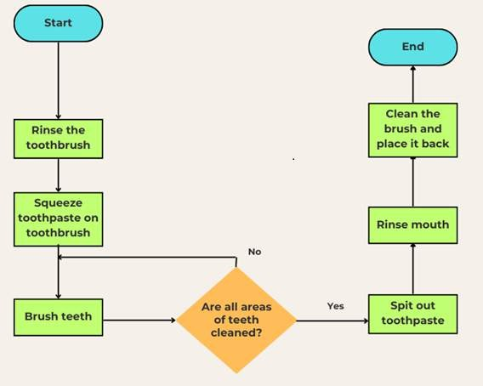

Figure 1.3: Flowchart for brushing teeth

  - Turning plans into code
Once we have planned our solution using computational thinking, algorithms, and flowcharts, the next step is to convert that logic into a language a computer can understand. This is done using check below comment

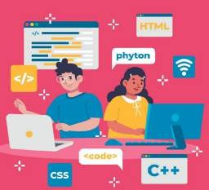
Figure 1.4: popular programming languages
A Programming language is a special way we write those set of instructions that tell a computer what to do. Just like we use different languages to communicate, programmers use programming languages to talk to computers.
It serves as a bridge between humans and machines. Each programming languages have unique syntax, rules, and purposes.

Some popular programming languages are as shown below.

Programming Language | Features
Python | Simple and easy to learn.
Java | Used for App and game development
C/ C++ | Used for hardware and embedded system
Table 1.2: Programming language and its features



AcTiViTY HuRdLES

Logo | Programming language
 | Python
 | JavaScript
 | HTML/CSS
 | Scratch

Recall we are going to use microcontroller board programming, as discussed in the previous session. Do you know which programming language is commonly used to program such microcontrollers?
Match the following programming languages to their logos.
It is C programming! In the next chapter we will begin our journey with C Programming.
    - Introduction to C programming
C is a powerful and widely used programming language. It is known for being fast and efficient, making it great for building software, games, and even operating systems.
C has a simple program structure with clear rules. It forms the foundation for many modern languages and applications.

Let us understand why C is preferred for board programming.

Advantages of C programming language
C is the preferred language for programming microcontrollers because of its many advantages as discussed below.

Feature | Meaning | Example
Efficiency | C talks directly to hardware →  hence works fast. |   Two people speaking same language hence achieve faster work.
Portability | Portability means the same C code can run on different  microcontrollers with just small code updates. |   Fitness tracker code reused on new model.
Access to hardware peripherals | C controls sensors and various devices easily. |   Smart doorbell controlling camera and mic..
Real time response | Real time response means C program reacts instantly without delay. |   Home automation responding quickly to commands.
Table 1.3: Advantages of C programming


Building Blocks of C
2



SESSion OVERViEw



In this session, you’ll start your journey into C programming by understanding the structure of C program, online compilers, and then you’ll write your first C program.

LEARning ObjEcTiVES

By the end of this session, you will be able to,
- Describe the basic elements of the C program
- Write your first C program
- Define comments in a C program
- Explain the online compiler to code the C program

Imagine writing a C program is like making a treasure map.The C program is equivalent to a map and its variables are like the landmarks guiding to the final treasure. Soon, you will learn about a variable in programming. As a map guides you step by step to the treasure, a C program runs line by line to produce the desired output.
So, let’s get started!

  - Introduction to C Program
As discussed earlier, C is widely used, efficiently, and the foundation for many advanced languages.
    - Basic Elements of the C Program
A C program consists of various fundamental elements that form the structure and logic of the code. Here are the key elements.
Imagine Ayush is getting ready for school. A C program works just like Ayush’s school day!

Figure 2.1: Ayush getting ready for school
- Preprocessor Directives
Before leaving for school, Ayush packs his bag, checks his timetable and adds the books he will need for the day.
In a C program, preprocessor directives do the same job. They prepare everything the program will need before it starts running.
#include <stdio.h>
This is like Ayush packing the“communication book”that helps him speak. Similarly, stdio.h helps the program use printf() to display messages on screen.
These directives start with a # symbol and tell the compiler (we will learn about it later) to include external files, to make the program more efficient. The directives like #include add external files to the C program.

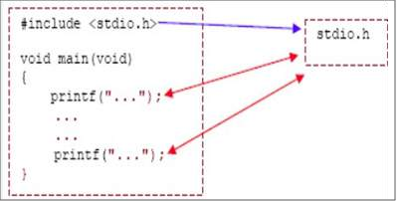
Figure 2.2: Preprocessor directives

  Figure 2.3: Preprocessor directive is like a library for C Programming | A library in C is like a school library made up of books. It is a set of pre-built tools (functions) that make programming faster and easier.  By including a library in your program, you can reuse its functions instead of writing them from scratch. This is done using preprocessor directives.

- Main() function
Once Ayush reaches school, enters the classroom, and his actual day begins.
The main() function is exactly that gate in the school. When the program reaches the main(), everything really starts.
int main() {
// the school day starts here
}
Nothing in the program happens until main() begins. Just like Ayush’s learning doesn’t begin until he enters class.
The C program execution begins with the main function. As the name suggests, it is a fundamental part of the program. The main() function is written as shown below.

int main()
{
/* ...*/
}

Figure 2.4: main() function
The main() function is written inside curly parentheses ‘{}’. Few code lines are written inside it, which directs a computer to perform the specific task. For example, print the messages on the screen or perform the addition of two numbers. These lines are called executable statements and are like the sentences in the story.
- Variable
Ayush keeps his important items such as lunchbox, notebooks, pencil case in his school locker. Each item has its own space.

Variables work the same way. They  are containers that store important information the program needs.  int bag= 10;  This is like saying:  “Ayush keeps 10 chocolates in his bag.”  In a C program, the numbers, words, or letters are stored in an imaginary container called a Variable. | For example, a C program has a variable named ‘num’ storing a number value of 10 as shown in the Figure 2.5.  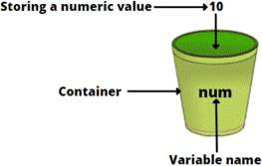  Figure 2.5: Variable
Let’s quickly revise the structure of the C program.

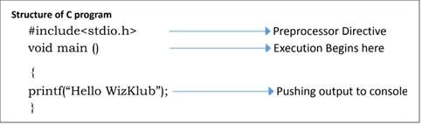
Figure 2.6: Structure of C program
Let’s discuss each code line-by-line.
- The first line of the program“#include <stdio.h>”is a preprocess or command or directive. This is not a part of our program, however this is an instruction to the compiler to include required header files to execute the specific set of instructions.
- The next line is “void main()” which is the main function where program execution begins. Each line in the function should be closed by a semicolon (;) which informs the compiler that the statement is closed.
- printf is another function used to print or display the statements on the screen. This set of statements must be enclosed in flower brackets ({}).

Syntax of a basic C program:

#include<> | Preprocessor directive
void main() | Start of C program
{ | Open flower bracket
Statement 1;  Statement 2; | Set of statements ending with a semicolon (;)
} | Closing flower bracket
    - Your First C Program
Are you excited to code your first C program? Write a C program to print “Hello, World!” Follow the code below to write the program.
#include<stdio.h> void main()
{
printf(“Hello, World!”);
}

Let’s understand meaning of each line!
- #include <stdio.h> → Gives access to input/output tools.
- void main() → Program starts here.
- printf(“Hello!”) → Displays text on screen.
- Save and run the code to display“Hello, World!”on the console.
    - Comments in the C program
After writing your first C program, it’s important to learn how to add comments in the program. Any idea what are comments in C program? Let’s explore the importance of comments in C!
Comments are a non-executable part of the C program. It means that the compiler ignores the comments written in the code during the compilation process and understands that those are only meant for the programmer’s understanding.
But how does it even recognise it as a comment?
There is a specific syntax to be followed while writing the comment. It’s like a code language that compilers understand and purposely ignore to compile. So, let’s learn the syntax of comments based on their type.

Single-line comment | Multiline comments
It starts with ‘//’. | It starts with /* and end with */.
 | Syntax:
Syntax:
 | /*Comment1......
// Comments | Comment2........
 | Comment3*/
 | Example:
Example:
 | /* This is a multi-line comment
// This is a single-line comment. | Name of the program
 | */
Table 2.1: Types of comments in C





GET SMART
Do you know that C was one of the first programming languages to formally support comments? It included support for both single-line and multiline comments.

  - Compiler in C Programming
When you talk to friends in the same language, you understand each other. But computers don’t understand C. As they only understand 0s and 1s (binary/ machine code).
To help, we need a translator called a compiler, which converts C programs (Source code) into a language the computer can understand!
The compiler converts C code into machine code so the computer can run it. This process is called compilation.
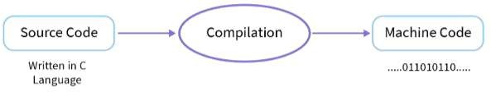
Figure 2.7: Compilation in C programming
    - Know Your Compiler
A C compiler translates C code into machine language (binary 0/1) so the computer can understand it. Below is the list of common C compilers.

C Compiler | Use
GCC cmoplier | Used for most C programs
Clang | Modern and fast compiler
MSVC (Microsoft Visual C++) | Used on windows computers
Turbo C | Used mostly in schools for learning
Table 2.2: Types of C Compilers
Different compilers work on different platforms to run C programs efficiently. However, we will be using Code::Blocks compiler for C programming.

Let’s take a quick look at how its dashboard looks.
Step 1: Open the Code::Blocks IDE (Integrated Development Environment) by double- clicking on its shortcut key on the screen as shown below.
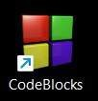
Figure 2.8: Code::Blocks Icon on the desktop
Step 2: This will launch the IDE, with Code::Block environment as shown in figure 2.9.
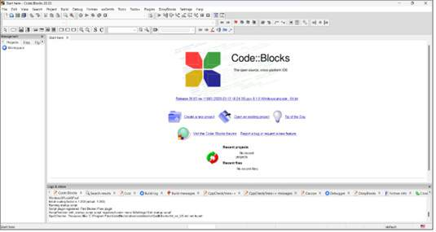
Figure 2.9: Code::Blocks Environment
Step 3: Next, click on the ‘File’ and then choose ‘New -> Empty file’ option to start writing the program.
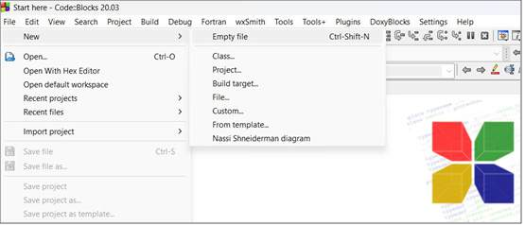
Figure 2.10: Begin with C program
Once the program is completed, then click on the‘Save’ icon to save it. Enter the appropriate file name such as ‘hello.c’ and click on the ‘Save’ button.

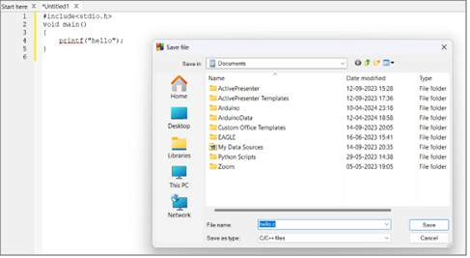
Figure 2.11: Save the C program
Observe that ‘hello.c’ extension is used for all C program files.
Step 4: To compile the C program, choose the ‘Build’ option as shown below.
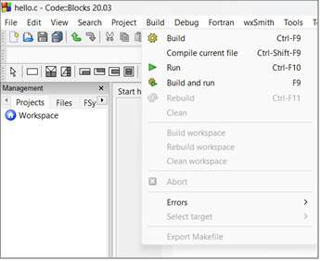
Figure 2.12: Compile the C program
Further, the compilation status will be shown in the ‘Build log’ at the bottom of the dashboard, as shown in figure 2.13.
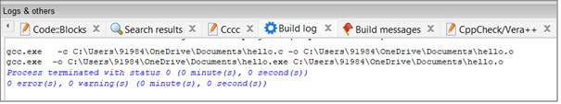
Figure 2.13: Build log

Step 5: Then, execute the C program using the ‘Run’ option as shown in figure 2.14.
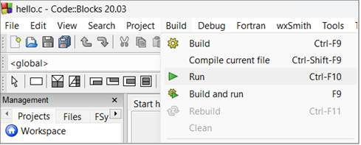
Figure 2.14: Compile the C program
Step 6: After successful execution of the C program, check its output on the console as given in figure 2.15.
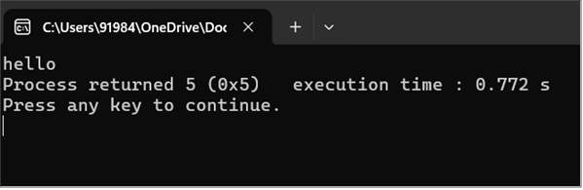
Figure 2.15: Output of the C program on console
Now that you know the insight of the Code::Block, go ahead and explore the magic of C programming!

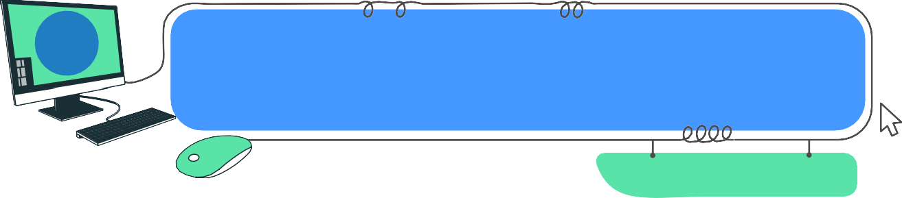
Get, Set Code
Lab Activity
3

Project: 1
Description: Write your first C program and print “Hello, World!”
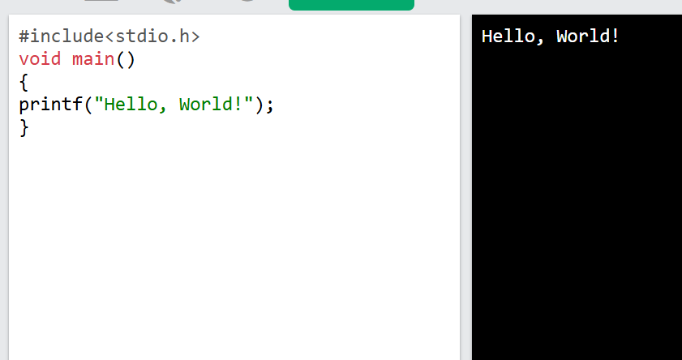

Project: 2
Description: Modify the previous program to print “Hello, World” on one line and numbers on a separate line within the same program.
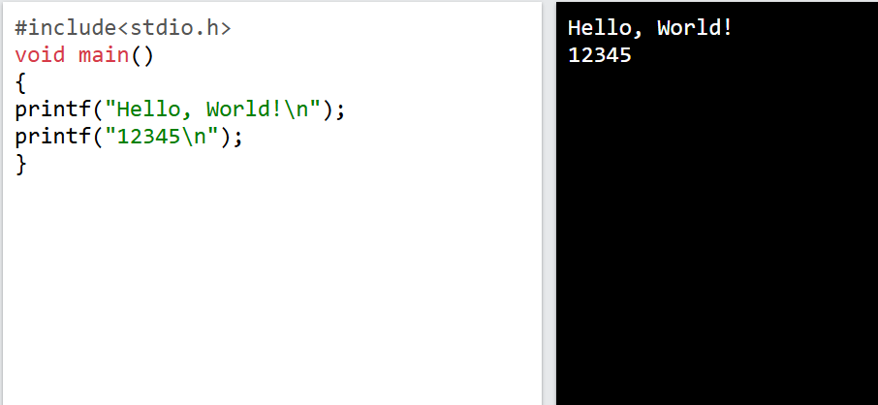

Project: 3
Description: How about documenting the purpose of ‘\n’ in the code, using a single-line comment?
